Atitit 思维导图 脑图工具

Xmasermid

Xmid 不好

幕布 title to 导图 凑活

Baidu echart

## 如何把标题作为导图？？

Word to mubu 还需要手动tab以下。。

思维导图图标类库 haosyo he ma haod..

## 思维导图图标类库选择

Baidu echart 好像 tree lydaosysotu tsabdae ,,,bo buhaoyong ..

Hichart haosyo yama

jsMind是一个纯javascript的思维导图类库，本代码使用jsMind展示了一个基础的思维导图。  
jsMind 项目主页： http://hizzgdev.github.io/jsmind/  
本代码示例：<http://hizzgdev.github.io/jsmind/example/1_basic.html>

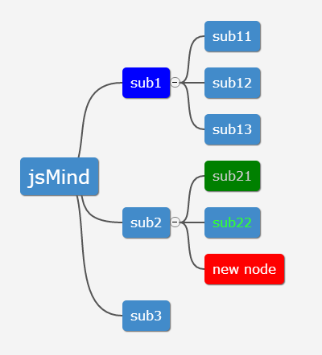

### [代码]**用jsMind显示一个简单的思维导图**

[?](https://www.oschina.net/code/snippet_1986752_37379)

|  |  |
| --- | --- |
| 1  2  3  4  5  6  7  8  9  10  11  12  13  14  15  16  17  18  19  20  21  22  23  24  25  26  27  28  29  30  31  32  33  34  35  36  37  38  39  40  41  42  43  44  45 | // 代码来源： http://hizzgdev.github.io/jsmind/example/1_basic.html    // 定义思维导图数据  **var** mind = {      "meta":{          "name":"example",          "author":"hizzgdev@163.com",          "version":"0.2"      },      // 支持三种数据格式，具体参见jsMind的文档      // https://github.com/hizzgdev/jsmind/blob/master/docs/zh/index.md      "format":"node_array",      // 如果你在数据库中存储思维导图的每一个节点，则使用node_array格式非常方便      "data":[          {"id":"root", "isroot":**true**, "topic":"jsMind"},            {"id":"easy", "parentid":"root", "topic":"Easy"},          {"id":"easy1", "parentid":"easy", "topic":"Easy to show"},          {"id":"easy2", "parentid":"easy", "topic":"Easy to edit"},          {"id":"easy3", "parentid":"easy", "topic":"Easy to store"},          {"id":"easy4", "parentid":"easy", "topic":"Easy to embed"},            {"id":"open", "parentid":"root", "topic":"Open Source"},          {"id":"open1", "parentid":"open", "topic":"on GitHub"},          {"id":"open2", "parentid":"open", "topic":"BSD License"},            {"id":"powerful", "parentid":"root", "topic":"Powerful"},          {"id":"powerful1", "parentid":"powerful", "topic":"Base on Javascript"},          {"id":"powerful2", "parentid":"powerful", "topic":"Base on HTML5"},          {"id":"powerful3", "parentid":"powerful", "topic":"Depends on you"},      ]  };  // jsMind的选项，更多参数参见jsMind的文档  // https://github.com/hizzgdev/jsmind/blob/master/docs/zh/index.md  **var** options = {      container:'jsmind_container',      editable:**true**,      theme:'primary'  }  **var** jm = **new** jsMind(options);  jm.show(mind);    // jm.set_readonly(true);  // var mind_data = jm.get_data();  // alert(mind_data); |

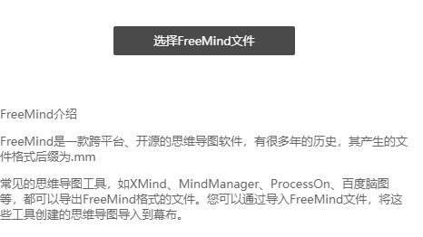

使用 JS 实现思维导图 - WEB前端 - 伯乐在线.html custm implt mind pic design